Project Report: Bitebytes
Introduction:
This project is a food delivery system designed to streamline the online ordering process. It consists of two main parts: a user-facing application and an admin panel. The user app allows customers to browse, add food to the cart, and place orders. The admin panel is where administrators can manage food items and view or update customer orders.
Features:
- User App:
  - Users can browse food items and view details like name, description, category, price, and image.
  - Customers can add items to their cart, proceed to checkout, and place orders.
  - The cart keeps track of all selected items and their quantities.
  - After placing an order, users can view their order history and track their order status.
- Admin Panel:
  - The admin can add new food items with details like name, description, price, and category. They can also upload an image for each item.
  - Admins can view the list of all available food items and delete items if necessary.
  - The order management section allows admins to see all orders placed by customers. Admins can update the order status, such as "Food Processing," "Out for Delivery," and "Delivered."
  - Notifications and alerts are provided using Toast messages for success or error actions.
Technology Stack:
- Frontend:
  - React.js for the user interface.
  - React Router to handle navigation between pages.
  - Axios for making HTTP requests to the backend API.
  - Toastify for showing notifications like success or error messages.
- Backend:
  - Node.js and Express.js for handling API requests.
  - MongoDB (a NoSQL database) to store data related to food items, users, and orders.
- Authentication:
  - JWT (JSON Web Token) is used for user authentication. Tokens are generated during login and stored in the browser's local storage.
- File Storage:
  - Food item images are uploaded by the admin and stored on the server.
Database Structure:
- User Collection:
  - Stores user information such as name, email, password (hashed using bcrypt), and token.
- Food Collection:
  - Contains all the food items available, including their name, price, category, description, and image.
- Order Collection:
  - Records details of each order, including the items, user information, delivery address, and status.
Admin Panel Pages:
- Add Page:
  - This page allows the admin to add new food items. The form collects information such as the name, description, price, category, and image.
  - When the form is submitted, the data is sent to the backend, where the new item is added to the food database.
- List Page:
  - Displays a list of all food items available in the system. The admin can view details like the item name, category, price, and image.
  - Admins can also remove any item by clicking the delete button.
- Orders Page:
  - Shows all the customer orders with details like the food items, customer name, address, and total amount.
  - The admin can update the order status from "Food Processing" to "Out for Delivery" or "Delivered."

Flow of User Actions:
- User Side:
  - Users browse food items, add them to the cart, and proceed to checkout. When the user places an order, it is saved in the database, and the order information is available for the admin to manage.
- Admin Side:
  - The admin adds food items and manages the catalog.
  - They view incoming orders and update the status of each order as it progresses through different stages of processing and delivery.

SOME SCREENSHOTS:-
Sign up page :-
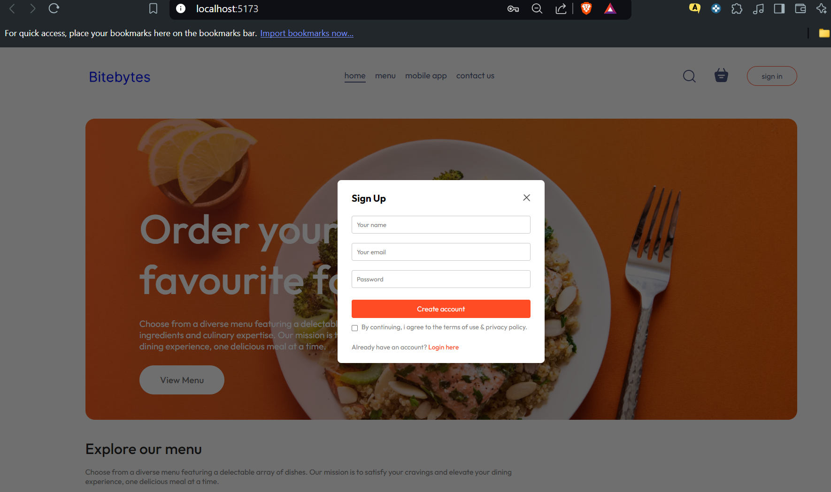

Cart page :-
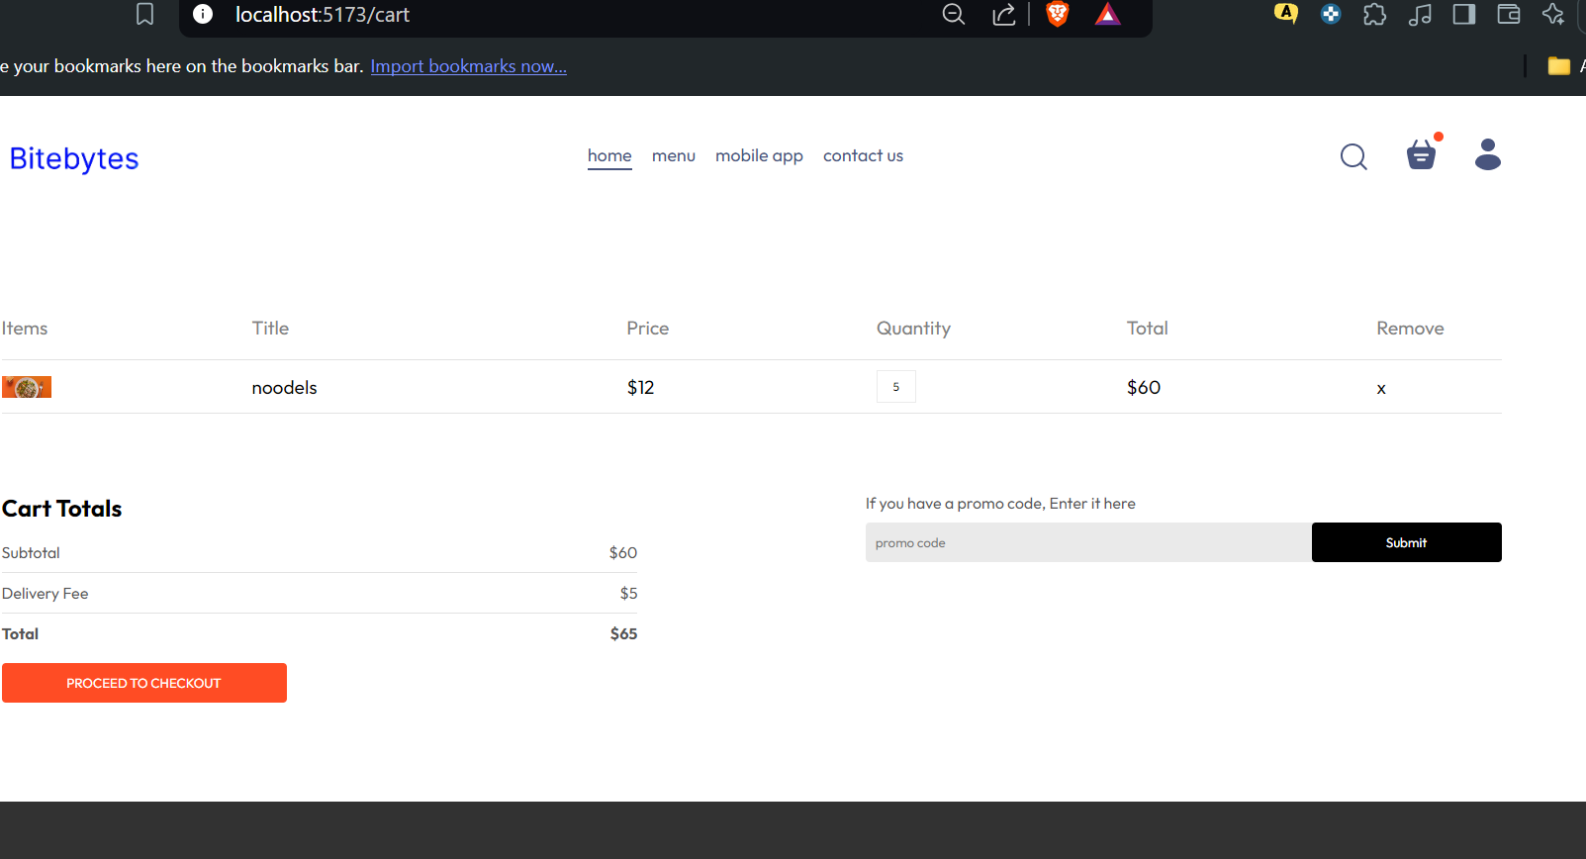

Place order page:-
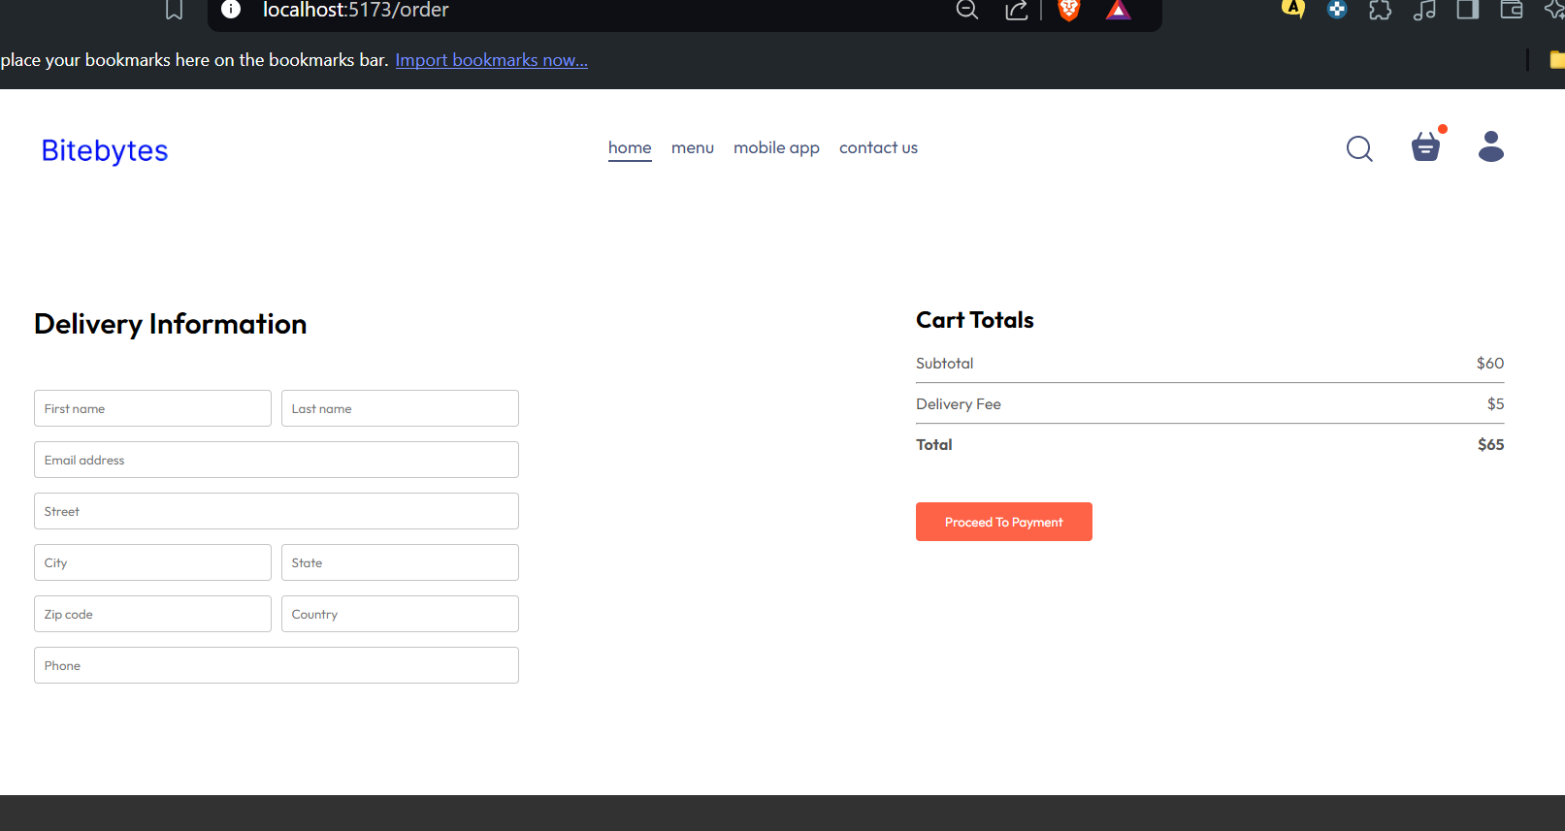

ADMIN SIDE:-
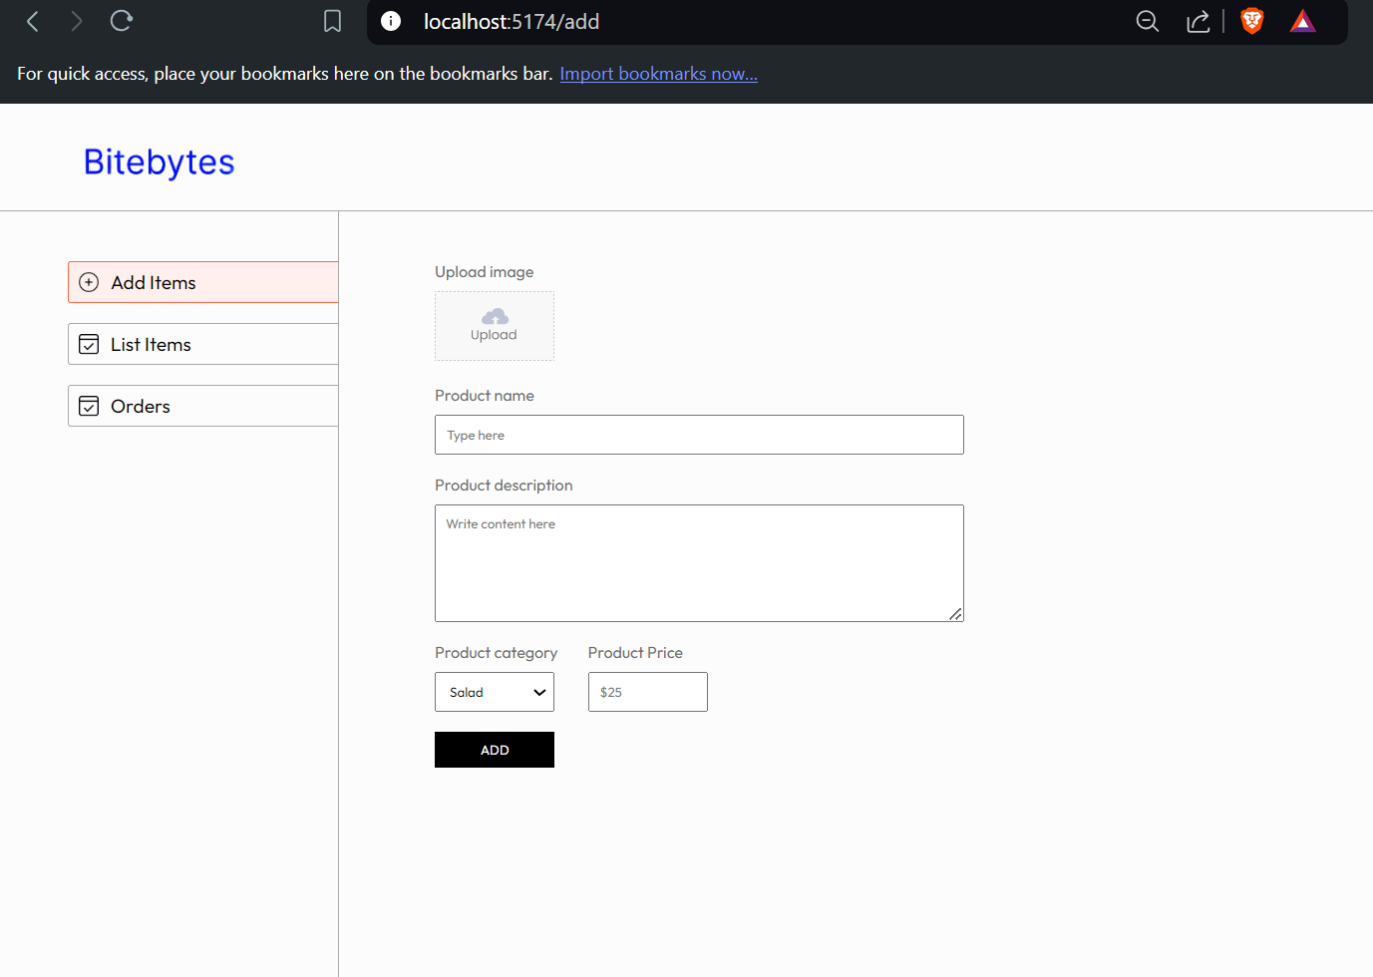

Conclusion:
The food delivery application is a simple yet effective system that handles both customer interactions and administrative tasks. By utilizing modern technologies like React.js, Node.js, MongoDB, and JWT for authentication, the project offers a smooth user experience and a powerful admin interface for managing a food delivery service.

